**晋 城 职 业 技 术 学 院**

2021–2022学年第1学期

**煤层气地质**

**教 案**

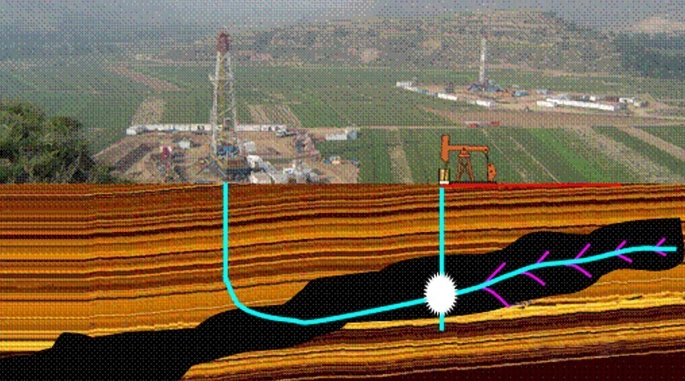

|  |  |
| --- | --- |
| **授课班级：** | **20级煤层气采输技术** |
| **任课教师：** | **张 双 斌** |
| **教学系：** | **矿 业 工 程 系** |

## 目录

目录 I

任务一 1

## 任务一

|  |  |  |  |  |
| --- | --- | --- | --- | --- |
| **授课信息** | | | | |
| **授课形式** |  | **教学方法** |  | |
| **授课地点** |  | **授课学时** |  | |
| **教学目标** | | | | |
| **知识目标** |  | | | |
| **能力目标** |  | | | |
| **思政目标** |  | | | |
| **重点难点** | | | | |
| **教学重点** |  | | | |
| **教学难点** |  | | | |
| **教学过程** | | | | |
| **教学环节** | **教学内容** | | | **课程思政** |
| **课前准备** |  | | |  |
| **课中教学** |  | | |  |
| **课后拓展** |  | | |  |
| **教学反思** | | | | |
| **学习效果** |  | | | |
| **反思改进** |  | | | |

## 任务二

|  |  |  |  |  |
| --- | --- | --- | --- | --- |
| **授课信息** | | | | |
| **授课形式** |  | **教学方法** |  | |
| **授课地点** |  | **授课学时** |  | |
| **教学目标** | | | | |
| **知识目标** |  | | | |
| **能力目标** |  | | | |
| **思政目标** |  | | | |
| **重点难点** | | | | |
| **教学重点** |  | | | |
| **教学难点** |  | | | |
| **教学过程** | | | | |
| **教学环节** | **教学内容** | | | **课程思政** |
| **课前准备** |  | | |  |
| **课中教学** |  | | |  |
| **课后拓展** |  | | |  |
| **教学反思** | | | | |
| **学习效果** |  | | | |
| **反思改进** |  | | | |