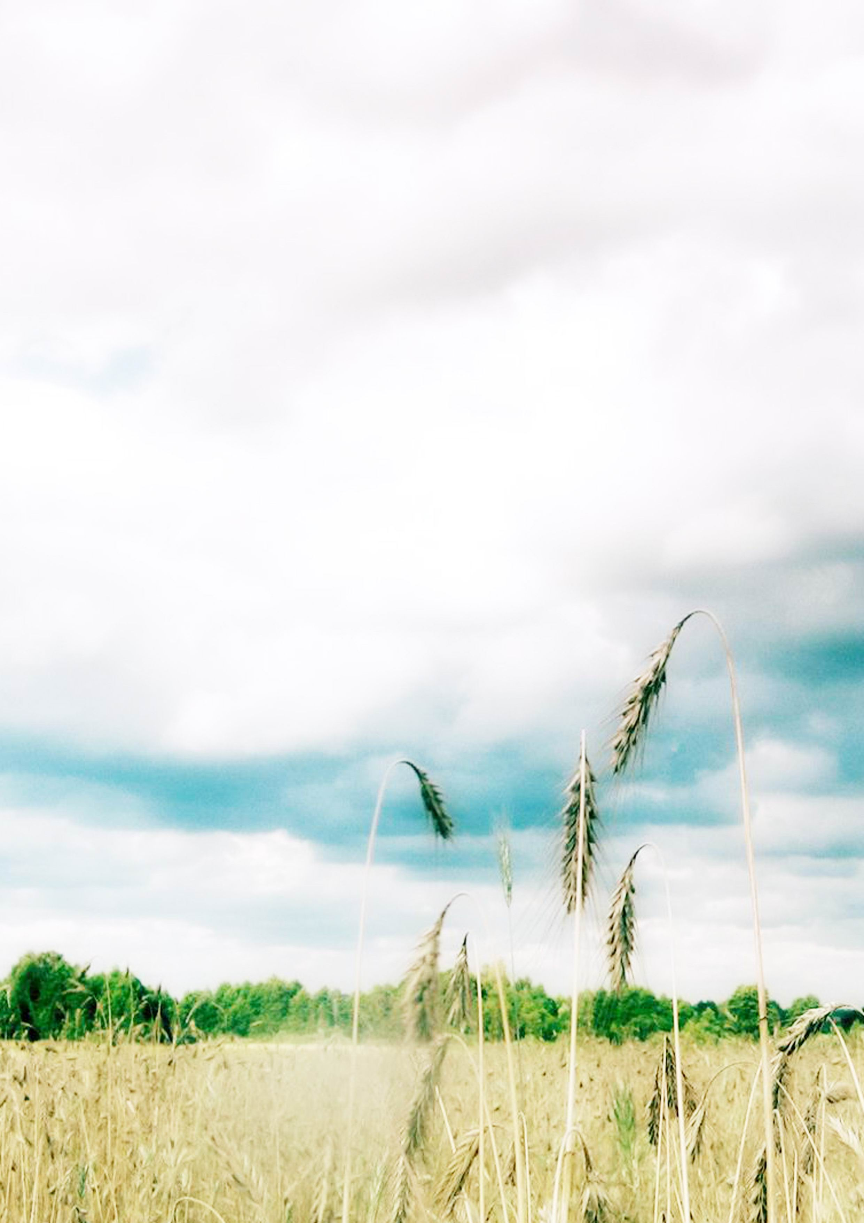
Mt. Taishan

1. Natural Features
Mount Taishan, with its main peak rising 1 545 meters above sea level, in central Shandong Province, has, since ancient times, been a mountain held in high esteem by the Chinese people. It is known as the “First of the Five Sacred Mountains”, all situated on the Central Plains of the country. It ranks third among the five mountains in terms of height.
According to historical records, Mount Taishan became a sacred place haunted by emperors to offer sacrifices and meditate in the Zhou Dynasty over1 000 years before the Christian era. A total of 72 emperors were recorded as visiting it. Men of letters also came to acquire inspiration, to compose poems, write essays, paint and take pictures. Hence, a great many cultural relics were left on the mountain.
Mt. Taishan has a long history, ancient geological stratum, graceful scenery, and a wealth of cultural relics and sites. Apart from others, those that have been admired with a name amount to 112 peaks, 98 cliffs, 18 caverns, 58 weird crags, 102 streams, 56ponds and falls, and 64 mountain springs, in addition to 22 ancient temples, 97 primeval sites, 819 stone steles, and 1 018 cliff inscriptions.
Mt. Taishan has rich biological resources. All over the mountain are ancient trees and flourishing grass, and the vegetation covers79.9% of the area. The zonal vegetation is warm-temperate deciduous broad-leaved forest, with a diverse flora comprising 989 species of seed plants in 144 families. Trees that are over 100 year old exceed 10 000 in number.
Mt. Taishan was always the symbol of monarchy in history. It was a sacred mountain to the kings and emperors, who would all came to offer their Fengshan Sacrifice ceremony, a gratitude worship to the heaven and earth the moment they assumed the crown or in the year of peace and abundant harvest. Before Qin Dynasty altogether 72 kings or emperors had their Fengshan ceremonies at Mt. Taishan, and from Qin Dynasty to Ming and Qing Dynasty emperors of all times had 27 such worship ceremonies at this mountain. As the only one of the mountains in China that enjoyed this honor from the emperors, Mt. Taishan is naturally rich with historical and cultural traces.
Mt. Taishan is a microcopy of the thousands years old civilization of China that contains a cultural wealth no other mountain in the world is comparable. Just like the Great Wall, Yellow River, and Yangtze River, Mt. Taishan is now the symbol of Chinese people.
In December of 1987, UNESCO inscribed Mt. Taishan on the World Heritage List as both a natural and a cultural property of the whole world.
2. Special Mention
From the town of Tai’an at the mountain foot about 150m above sea level, up to Mediate Heaven Gate 847m above sea level, then atop the summit Jade Emperor Summit 1 545m above sea level, the peaks along and around the way rise and roll to contrast the summit with a rhythm from restraint to released as well as a lofty expanse that belittle all other mountains. Emperor Wu of Han Dynasty was so overwhelmed on his visit that he said, “Mt. Taishan is so high, extremely high; so big, unusually big; so magnificent, very conspicuous; so daunting and so amazing.”
Mt. Taishan wonders include: Brilliant Sunrise; Jade Plate of Cloud Sea; Pure Rime; Buddha’s Halo; Rosy Sunset.
3. Major Scenic Sites
“Imperial Road” tour route: Red Gate Place
All Fairies Tower
Goddess Doumu Palace
Sutra Rock Valley
Mediate Heaven Gate
Eighteen Bends
South Heaven Gate
West tour route: Tianwai Village
Gragon Pond Reservoir
Jiandai Bridge
Sesame Oil Valley
White Dragon Pond
Horse Hoof Ravine
Heaven Obedient Bridge
Heavenward Bridge
Yellow Inkstone Ridge
The foot zone of Mt. Taishan: Temple to Heavenly Queen Mother
Tiger Mountain Park
Universal Light Temple
General Feng Yu-xiang’s Tomb
Heaven Candle Peak tour zone: Rear Rock Basin
Jade Spring Temple
Heaven Candle Peak
Divine Rock Temple tour zone
Fan Cliff tour zone
Peach Blossom Ravine tour zone
4. Other Attractions Around the Place
Dai Temple
The remains of the ancient State Qi Great Wall
Qufu---Confucius’s birthplace

